Course Title: Webpage Design

Course Code: ITEC 240

CRN: 236904

Student Name: Malachi Alexis

Student ID: 00039039

Lecturer: Mrs Nicole Alexander

Trinbago sports uniforms LTD.

|  |  |  |
| --- | --- | --- |
| Image result for home | Image result for products | Image result for contact us |
| Trinbago Sports Uniforms LTD, is a limited liability company that specializes in the production of sporting uniforms and accessories. We cater uniforms for all sporting disciplines, and we supply uniforms to schools, institutions both public & private and any other corporation who desires our business.  **Mission**: To be the Supreme supplier of ***ALL*** sporting gear and supplies in the Caribbean. | | |
| Image result for swimming clipart Swimming Image result for basketball Basketball Image result for aikidoKarate | | |



 Tennis  Football  Cricket 





|  |
| --- |
| Image result for copyright symbol2018. Malachi Alexis 00039039 |



  

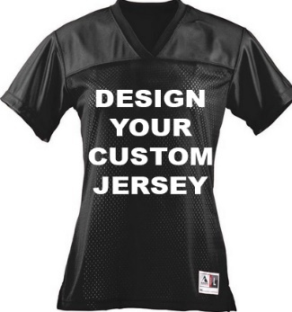 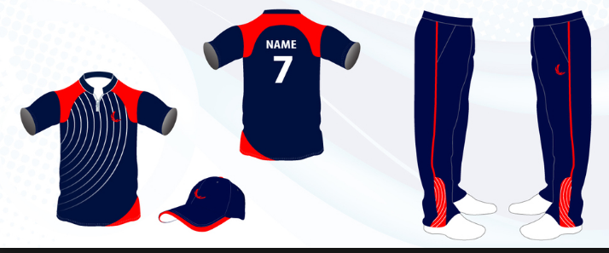

  



Address: LP 63 Eastern Main Road, San Juan.

Telephone: (+1868) 555-5555.

Fax: 1868-555-8888.

Email: [Trinbagosportsuniform@gmail.com](mailto:Trinbagosportsuniform@gmail.com)

Google Map:

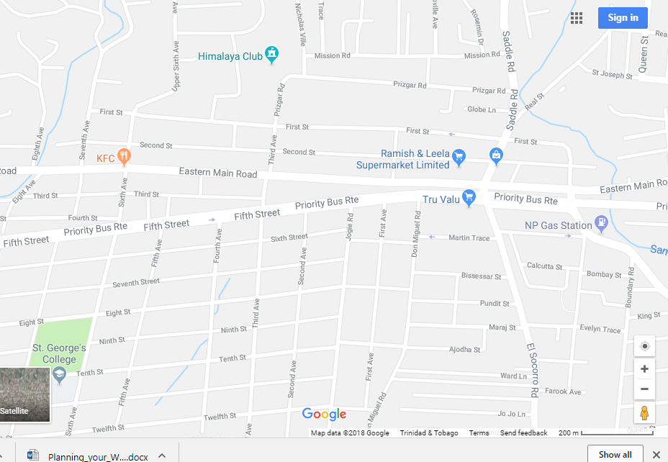



Student Name: Malachi Alexis

Student ID: 00039039

Director of Operations at Trinbago Sports Uniform Ltd.